7th International conference on
Chemical Reactions in Foods
14 – 16 November 2012, Prague, Czech Republic

REGISTRATION FORM (ExhibitION & SPONSORSHIP)

All sponsorship, exhibition & business opportunities are available on a first come first served basis.

Please complete this registration form and send it to the e-mail address of Exhibition manager Monika Tomaniova (monika.tomaniova@vscht.cz).

Company name: | Contact person:
VAT no. (must be completed):
Street:
City:
Postal code:
Country:
Phone:
Fax:
E-mail:

EXHIBITION
COMPANY PRESENTATION AT THE CONFERENCE ACCOMPANYING EXHIBITION:
EXHIBITION PACKAGE 1 € 2 000*
Exhibition space of 6 sq. m within the accompanying exhibition of the conference (including tables, chairs, power supply, poster board – if required)
Promotional materials (advertising leaflets / CDs or pens plus notepads) in the conference bags
Logo on the home page of the conference linked to the company website
The integration of the logo on the conference notice board(s) and in the Book of Abstracts
One free symposium registration for exhibiting staff**
One free ticket for Conference dinner
EXHIBITION PACKAGE 2 € 1 200*
Exhibition space of 4 sq. m within the accompanying exhibition of the conference (including table, chairs, power supply – if required)
Logo on the home page of the conference linked to the company website
The integration of the logo on the conference notice board(s) and in the Book of Abstracts.
One free symposium registration for exhibiting staff**
* or corresponding amount in CZK, the prices do not include VAT and insurance
** free registration includes full attendance at the conference, the final program, the book of abstracts, coffee breaks, luncheons and a welcome drink

Please specify preferred BOOTH NUMBER:
Masaryk College conference centre - EXHIBITION floor plan

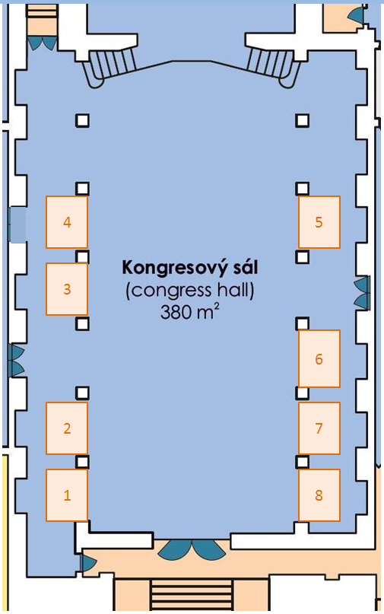
PLEASE SPECIFY REQUIRED ADDITIONAL OPTIONS AND SERVICES
(even if included in the fee for the booth of your choice):

ADDITIONAL SERVICES (on request): |  | Please mark the option you have chosen & Number
Promotional materials (advertising leaflets / CDs) into conference bags  No more than 3 lightweight leaflets á 12 pages / CD  (Costs included in the price for EXHIBITION PACKAGE 1) | € 300*
Literature display  per 1 item | € 150*
Socket  (Costs included in the price for both Exhibition packages) | Free of charge | How many?
INTERNET connection  (LAN, 1 MB) | € 20 / day* | How many?
Poster board  (height 130 cm, width 95 cm)  (Costs included in the price for EXHIBITION PACKAGE 1) | € 30* | How many?
Table  (additional) | Free of charge | How many?
Chair  (additional) | Free of charge | How many?
* or corresponding amount in CZK, the prices do not include VAT

You will not be charged for services which are included in the exhibition package you have selected.

Please specify any additional requirements, e.g. concerning the installation of instruments etc.:

SPONSORSHIP
Type of the sponsorship | Please mark the option you have chosen | Price
Conference Book of Abstracts  Sponsorship the Book of Abstracts allows you to have a two full coloured page advertisement in the Book of Abstracts.  Integration of the logo on the home page of the conference with a link to the company website and on the conference notice boards. |  | € 1 500*  Platinum sponsorship
USB key  All registered participants will receive an USB key in their bags. Book of Abstracts and promotional materials of your company will be uploaded on the USB key.  Providing the USB keys with company name / logo allows you to insert it into the conference bags.  Integration of the logo on the home page of the conference with a link to the company website and on the conference notice boards. |  | Full costs – provided by company  Platinum sponsorship
Internet corner  2 PCs with high-speed Internet connection  Company logo on the computer terminal screen savers  Company website as default homepage on the terminals  Company advertising notice board in the area of Internet corner  Integration of the logo at the home page of the conference with a link to the company website and on the conference notice boards. |  | € 1 500*  Platinum sponsorship
Final Program  Sponsorship the Final Program allows you to have full, page coloured advertisement on the back cover of the Final program.  Integration of the logo on the home page of the conference with a link to the company website and on the conference notice boards. |  | € 1 000*  Gold sponsorship
Conference bags  Supply of symposium bags for the participants of the conference (printing must include the symposium name and the logos of the three organizing bodies).  Supplying the Conference bags allows you to print your logo on the bag and include promotional materials into the bags.  Integration of the logo on the home page of the conference with a link to the company website, on the conference notice boards and in the Book of Abstracts |  | € 1 000*  Gold sponsorship
Pens  All registered participants will receive a pen in their bags. Providing the pens with company name / logo allows you to insert it into the conference bags.  Integration of the logo on the home page of the conference with a link to the company website and on the conference notice boards. |  | Full costs – provided by company  Silver sponsorship
Type of the sponsorship | Please mark the option you have chosen | Price
Notepads  All registered participants will receive a notepad in their bags. Providing the notepads with company name / logo allows you to insert it into the conference bags.  Integration of the logo on the home page of the conference with a link to the company website and on the conference notice boards. |  | Full costs – provided by company  Silver sponsorship
Lanyards  Providing the lanyards with company name / logo allows you to use it for conference participant’s badges.  Integration of the logo ot the home page of the conference with a link to the company website and on the conference notice boards. |  | Full costs – provided by company  Silver sponsorship
Gifts for delegates conference bags  All registered participants will receive a gift within their conference materials.  The sponsor may place its logo in a card to be included with the gift or on the gift. (Excluding gift, to be provided by sponsor company).  Integration of the logo on the home page of the conference with a link to the company website and on the conference notice boards. |  | Full costs – provided by company  Silver sponsorship
Poster award  Award on behalf of company for selected poster. |  | € 500
Welcome Cocktail  November 14, 2012  Venue: Masaryk College Conference Centre  Welcome Drink for participants, accompanying persons and guests of the meeting.  Being a sponsor of the Welcome Drink means integration of your logo on the invitation cards, and in the Program, on the home page of the conference with a link to the company website, on the conference notice boards and in the Book of Abstracts and on-site signage during the evening to include a variety of branded signs. |  | Open sponsorship  Any kind of contribution  Type of the sponsorship depends on the contribution
Conference Dinner  November 15, 2012  Venue: Slavia restaurant  Conference Dinner for participants, accompanying persons and guests of the meeting  Being a sponsor of the Conference Dinner means integration of the logo on the desert, on the invitation cards and Program of the conference, on the home page of the conference with a link to the company website, on the conference notice boards and in the Book of Abstracts and on-site signage during the evening to include a variety of branded signs.  2 tickets for Conference dinner |  | Open sponsorship  Any kind of contribution  Type of the sponsorship depends on the contribution
Type of the sponsorship | Please mark the option you have chosen | Price
Conference Coffee Break(s)  Coffee break(s) for conference participants according to the program of the conference  Being a partner of Conference Coffee break(s) means integration of the logo on the home page of the conference with a link to the company website and on the conference notice boards and on-site signage during the coffee break / refreshment to include a variety of branded signs. |  | Open sponsorship  Any kind of contribution  Type of the sponsorship depends on the contribution
Conference Lunch(es)  Lunch / brunch for conference participants according to the program of the conference  Being a partner of Conference Lunch(es) means, integration of the logo on the home page of the conference with a link to the company website and on the conference notice boards and on-site signage during the buffet lunch to include a variety of branded signs. |  | Open sponsorship  Any kind of contribution  Type of the sponsorship depends on the contribution
Other suggestions
For any other suggestion on sponsorship not mentioned above, please contact the exhibitor manager.
* or corresponding amount in CZK, the prices do not include VAT
Additional Sponsorship Opportunities might be added without prior notice. Conference organizers reserve the right to offer some items to more than one sponsor.
Please note that full contact details of all delegates will not be available to an exhibitor or sponsor due to the data protection restrictions. The provision of delegate contact details is not considered as a part of any booking.
BOOKING / PAYMENT TERMS & CONDITIONS
Terms of Payment:
Acceptance of application for exhibition or sponsorship is at the discretion of the organizers.
Once you have agreed a specific exhibition or sponsorship option with the exhibition manager, the total amount will be invoiced after sending of the completed registration form. Checks will not be accepted, only wire transfers.
Your claim for a specific exhibition or sponsorship option will become firm when your payment has been received and confirmed.
Cancellation Policy:
If you find it necessary to cancel your exhibition or sponsorship, please notify the exhibition manager immediately. Cancellations must be received in writing.
Provided that written notice is received before 31 August 2012 a full refund will be given, less a 10% administrative charge.
It is regretted that for cancellations from 1 October 2012, or for no-shows at the conference, the full sponsorship fee (100% cancellation charges) will be payable.
Reimbursements will be sent until 60 days after the conference.
Liability:
Conference participants are advised to arrange whatever insurance they consider necessary. The organizers cannot accept any liability for loss or damage of properties, injuries, unexpected events, travel delays, non-appearance of specific speakers, program changes.
Conference participants will be liable to the organizers for any damage caused by them occurring in the course or in direct connection with the event.

DEADLINES & IMPORTANT DATES
August 31, 2012 Deadline for registration as an Exhibitor or Sponsor
August 31, 2012 Deadline to provide company logo and other advertising materials for the Book of Abstracts
October 1, 2012 Floor plan and other information for exhibitors & sponsors available
October 14, 2012 Deadline to provide all materials for the conference participants (inserts into the bags, lanyards, pens, notepads, USBs etc.)
November 14, 2012 Set-up of the exhibition from 8:00
November 16, 2012 Dismantling of the exhibition from 14:00

For other deadlines, important dates and information on the conference organisation please see conference website at www.crf2012.eu.

Date:
In:
Name:

